Travelling Salesman Problem in Python:
Aim:
To implement a Python program to solve the Travelling Salesman Problem (TSP) using search algorithm in Artificial Intelligence.
Objective:
- Implement the Travelling Salesman Problem (TSP) in Python.
- Find the minimum-cost route that visits every city exactly once.
- Return to the starting city after visiting all cities.
- Understand optimization problems in Artificial Intelligence.
Algorithm:
- Start the program.
- Define the distance (cost) matrix representing the distances between all cities.
- Select one city as the starting city.
- Generate all possible permutations of the remaining cities.
- For each possible route:
  - Begin from the starting city.
  - Visit each city exactly once.
  - Return to the starting city after visiting all cities.
- Calculate the total travel cost for each route.
- Compare the total cost with the current minimum cost.
- If the current route has a lower cost, update the minimum cost and store the route.
- Repeat Steps 5–8 until all possible routes have been evaluated.
- Display the optimal route and its minimum travel cost.
- Stop the program.

Flow Chart:
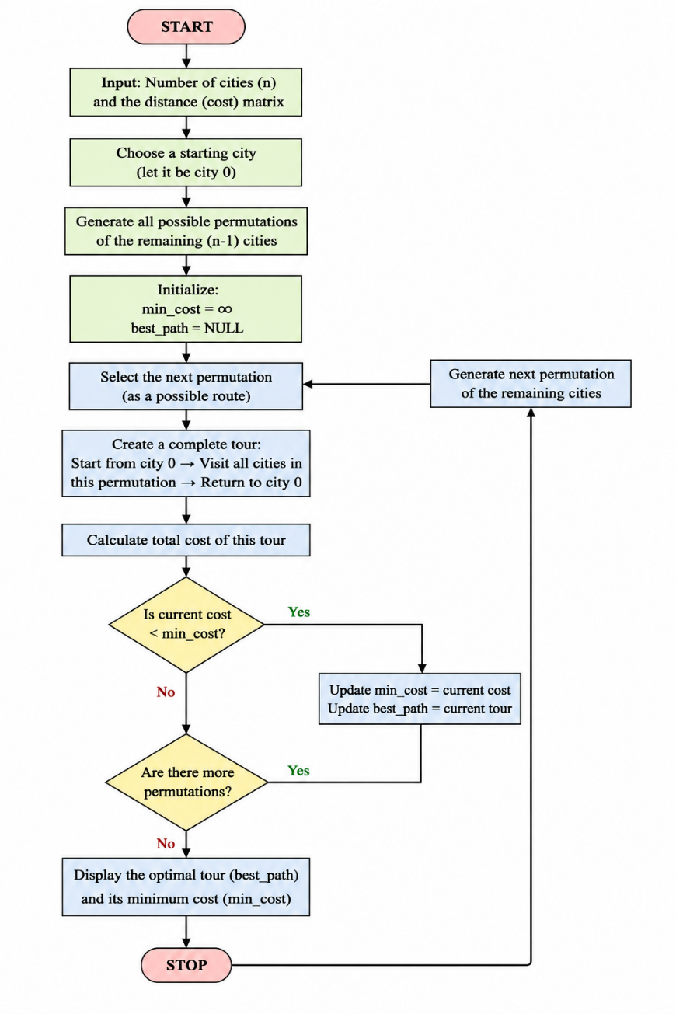
Python Code:
from itertools import permutations
# Function to solve TSP
def travelling_salesman(graph, start):
n = len(graph)
vertices = []
# Store all cities except the starting city
for i in range(n):
if i != start:
vertices.append(i)
min_cost = float('inf')
best_path = None
# Generate all possible paths
for path in permutations(vertices):
current_cost = 0
current_path = [start]
k = start
# Calculate the cost of the current path
for city in path:
current_cost += graph[k][city]
current_path.append(city)
k = city
# Return to the starting city
current_cost += graph[k][start]
current_path.append(start)
# Update minimum cost and best path
if current_cost < min_cost:
min_cost = current_cost
best_path = current_path
return min_cost, best_path
# Distance (Cost) Matrix
graph = [
[0, 10, 15, 20],
[10, 0, 35, 25],
[15, 35, 0, 30],
[20, 25, 30, 0]
]
start_city = 0

cost, path = travelling_salesman(graph, start_city)
print("Optimal Path:")
print(" -> “. join (map (str, path)))
print("Minimum Cost =", cost)
Sample Output:
Optimal Path:
0 -> 1 -> 3 -> 2 -> 0
Minimum Cost = 80
Result:
